Employment Org Design & Talent App
Sarah Biggs

Part 1 Problem and Motivation

Describe the purpose of your application.
The purpose of my application is to provide an easier way to track work that is aligned with individual employees. The main problem I am trying to solve is that when an employee leaves a department, it can be difficult to clearly understand what work they were responsible for, what skills are needed to replace them, and how that decision fits within the department’s broader staffing needs and budget.
Rather than approaching staffing decisions in a purely reactive or ad-hoc way, this application would help departments think more strategically about what skillsets they currently have, what skillsets they may be missing, and what type of position or employee profile would best support the organization moving forward.
This problem is interesting and important to me because I work in HR, and I can see how a tool like this could support organizational development conversations. Leaders often need to make staffing decisions quickly, but they may not always have a clear picture of the work being done across a team or how responsibilities are distributed. An application that helps visualize this information could make those conversations more data-informed and intentional.
The solution I plan to create is an interactive application that allows users to explore staffing-related data, view relationships between employees and work responsibilities, and better understand organizational needs.

Identify the intended users.
The intended users for this application are HR staff, particularly HR Business Partners (HRBPs). HRBPs often work directly with business leaders to think through staffing plans, organizational structure, open positions, and workforce needs. This application would support that work by giving HR staff a more organized and visual way to understand employee responsibilities and staffing gaps.
The application would benefit users by helping them advise business leaders on staffing and organizational planning. For example, if an employee leaves, HR staff could use the application to better understand the work connected to that person, the skills associated with that work, and how those responsibilities relate to the rest of the department.
The application would provide an interactive way to view aggregate data, visualize open positions, and display an organizational chart. Ideally, it would help users move from a general understanding of staffing needs to a more specific understanding of what roles, skills, or responsibilities may need to be addressed.

Part 2 Data and Database Design

Data Source & Description
The original data was taken from a raw Kaggle dataset, called Fake Employee Dataset (Oyekanmiolamilekan, n.d.). The data, as can be derived from the name, is taken from real employment circumstances. Because the data are fake, some of the values may not be perfect or make the most sense, but it will do for the sake of prototyping the value the database might offer to HR professionals. However, this data is quite dirty and is not taken from completed Kaggle project.
The data are structured in the form of a CSV, downloaded from Kaggle with 24 columns and 1000 rows. Each row is a unique employee, and the attributes define their demographics, job, and employment status. Notably, Kaggle’s site list 25 attributes, including an “Employee Satisfaction Score,” but the dataset did not include that attribute. That would be excellent data to have, but since it wasn’t included in the final dataset I was able to pull, I won’t include it in the database. Below is a table of each attribute and its definition, taken directly from Kaggle (Oyekanmiolamilekan, n.d.):
Attribute | Attribute Definition (from Kaggle)
Employee ID | A unique identifier for each employee.
Name | First name and last name of the employee.
Gender | Male, female, non-binary, etc.
Date of Birth | Birthdate of the employee.
Email Address | Contact email of the employee.
Phone Number | Contact number of the employee.
Address | Home or work address of the employee.
Department | The department the employee belongs to (e.g., HR, Marketing, Engineering, etc.).
Job Title | The specific job title of the employee.
Manager ID | ID of the employee's manager.
Hire Date | Date when the employee was hired.
Salary | Employee's salary or compensation.
Employment Status | Full-time, part-time, contractor, etc.
Employee Type | Regular, temporary, contract, etc.
Education Level | Highest level of education attained by the employee.
Certifications | Any relevant certifications the employee holds.
Skills | Specific skills or expertise possessed by the employee.
Performance Ratings | Ratings or evaluations of employee performance.
Work Experience | Previous work experience of the employee.
Benefits Enrollment | Information on benefits chosen by the employee (e.g., healthcare plan, retirement plan, etc.).
Work Location | Physical location where the employee works.
Work Hours | Regular working hours or shifts of the employee.
Employee Status | Active, on leave, terminated, etc.
Emergency Contact | Contact information of the employee's emergency contact person.

The data above are a decent synopsis of common employee data that HR regularly works with perform analyses for the sake of decision-making, particularly during talent reviews and department reorganizational activities. Below I’ll detail how I’ll clean the data to make it most useful for the sake of the final application and database.
First, some basic preprocessing will include separating first and last name into separate fields. From a user perspective, having these separate will most easily allow a leader to search the application by last name in case they don’t know the employee’s ID number. I’ll probably also add an age attribute, derived from date of birth. This is considered sensitive data, but it is useful in trying to make retirement predictions. Similarly, I’d add a calculation to provide years of service as well, derived from Hire Date. The final basic cleaning step would be the actual values in the Work Hours column. It lists the data as both hours and shift type. I would clean this up to make it consistent. For example, instead of “9-5,” I would write it as “Day Shift,” or more accurately, “First Shift.”
Another type of preprocessing I’ll need to do is separating data (comma-separated list in each respective column) in the following three columns: skills, certifications, and benefits enrollment. These lists, as well as the Work Experience text-based column, bring up a significant cleaning process with this dataset.
Because this dataset was manufactured to be a prototype, some of these list-based columns were clearly created using a random word generator. Since this is a fake dataset anyway, my plan would be to utilize AI to enhance this dataset even futher to replace the values with something more appropriate. For example, one of the employees has the following skills listed in the dataset: “perhaps, knowledge, officer.” These are clearly random words and not skills, so I would feed each job title into a GPT to make the data better and replace it with something like, “communications, web development, media literacy.” Doing this will be necessary because a function of the app would allow an HR professional or leader to search their database by skill.
The final, even more significant preprocessing step will be randomly breaking up their skills into what skills are required for their job versus what skills they have outside of their job. Making this distinction is necessary when figuring out if an employee is ready to move into another role. For example, with the example skills I provided above, maybe that employee is a web developer. They probably need web development as a skill, but the fact that they have communications and media literacy as a skill may mean that they could be promoted into a leadership role within their department.
Finally, I likely will not be using the following fields: emergency contacts, phone number, address, and email.

Preliminary Database Design
Since I am unsure of the best way to prototype an ER-like model for my database, and since I have not fully loaded my cleaned dataset into Neo4j, I created a very basic, tentative design to show what I’m hoping to accomplish. I created the following screenshot using Draw.io.
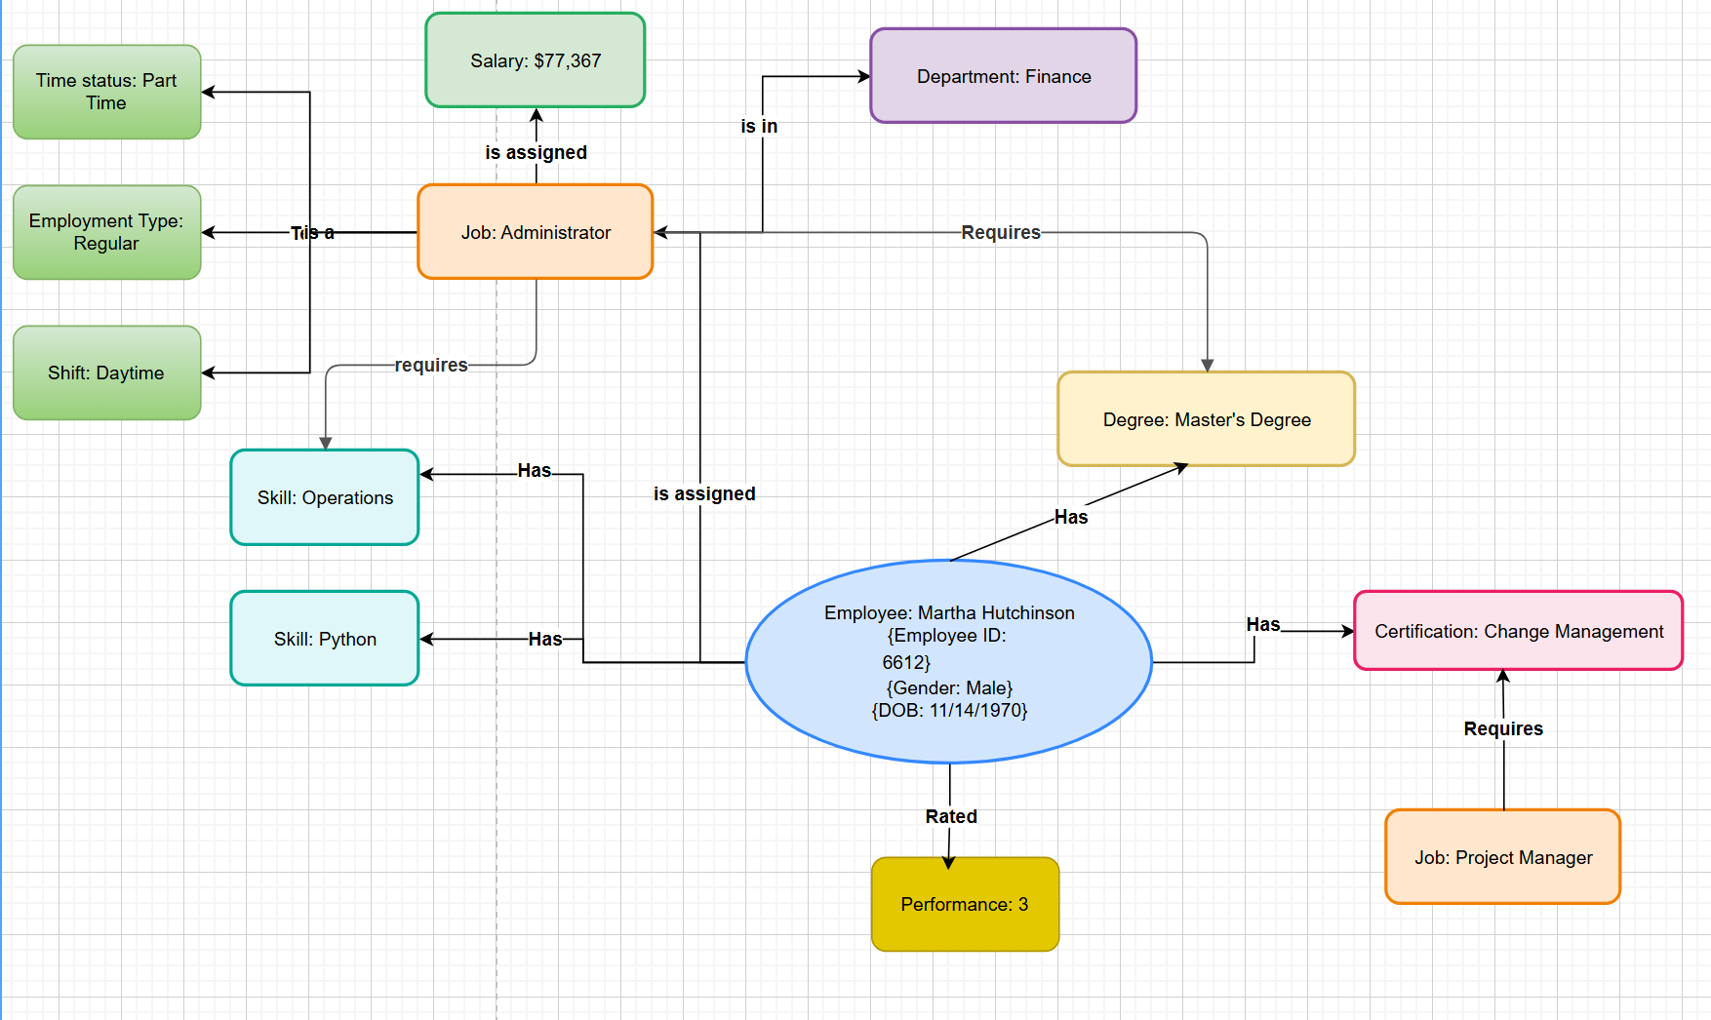
The main entities are the employee and their job. Everything else is considered in relation to those two entities. However, notice that many of these entities relate to both job and employee. For example, as discussed above, an employee can have a set of skills, but only so many may be required for their job. The same may be true for a degree or certification.
I have tired to articulate this nuance above by acknowledging that the central employee has a certification in change management, but that is not required for the job the employee actually has. It, however, is required for another type of job.
Ideally, the data will be separated into the following overarching entities: employees, jobs, skills, certifications, and departments. These will be the main ways users will try to find information from this database.

Part 3 Team and Project Organization

Projected Work
Since this is an individual project, my plan is to work alone to complete these tasks. However, I will use AI when it comes to actually coding the final application in Shiny. I will clean my dataset, create the database, write the cypher language to allow users to pull particular information from the database, using the app, and finally thought partner with AI on the design of the application (not database, just the user interface).

Technology Stack
I plan to use a Neo4j Aura instance in order to create my graph database. That seems to be a user-friendly, free way to upload my data and query it, as well as graphically visualize it.
I’m using a graph interface because I would like to learn how to use that database method/option better, and employee data seems like a great way to use it. Also, it provides a built-in way for users to see relationships without understanding the database design intuitively.
I also plan to use Shiny and Python to create my application, hosting the app in a GitHub Repo and using Posit Connect Cloud to connect to Neo4j. I have chosen to use these methods because I am familiar with Python and have written an application before, using Shiny. That was a couple of years ago at this point, but I understand it to be pretty easy for people with my skillset.
The application code will be stored in a GitHub repository, and I plan to deploy the app using Posit Connect Cloud. The Shiny application will connect securely to the Neo4j Aura database using stored environment variables or secret credentials, rather than exposing the database credentials in the code.

Deployment Plan
For deployment, my current plan is to host the graph database in Neo4j Aura and deploy the Shiny for Python application through Posit Connect Cloud. The application code will be stored in a GitHub repository, which Posit Connect Cloud can use to publish the application.
The application would be accessible through the public Shiny application link. The Neo4j database itself would remain secured with provided credentials, and the Shiny app would query the database in the background and display the relevant results to users. This setup should allow the project to be accessible without requiring users to install software or directly connect to the database.
I am still working through the details of deployment, but my goal is to create a cloud-based setup where the database and application are connected securely and the final app is easy for others to access and use.

Sources
Oyekanmiolamilekan. Fake Employee Dataset. Kaggle, n.d., https://www.kaggle.com/datasets/oyekanmiolamilekan/fake-employee-dataset. Accessed 27 June 2026.

